http://blog.pluralsight.com/resize-vmware-linux-drives

Resizing Linux drives in VMware | Give me my space part II
By Marco Shaw
There are potential issues that you can encounter when working with Server 2012 virtual machines, especially around resizing drives. Using vSphere 5.1, ESXi 5.1 host, and VMware tools with Red Hat Enterprise Linux 6.4, I wanted to start a discussion on how to resize drives in Linux.

Using a simple example
When I resized Server 2012 drives in VMware, I chose to work with a 40 GB base disk. I’m going to go with a 20 GB drive this time around.
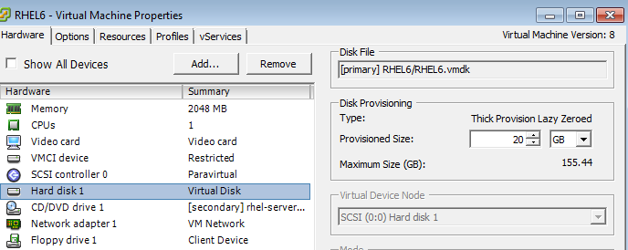
I did a pretty basic install of RHEL, but most importantly, I chose to set up my system using Linux logical volumes for my disks, which is the default. I had to customize my setup because I chose to define two logical volumes for / and /home, and placed them in a single volume group.
For someone new to Linux, or that hasn’t worked with other logical volume managers, this terminology might be completely new to you. Describing the Linux logical volume manager is beyond the scope of this post, but I hope everyone is able to follow along and maybe learn something new.
When learning something new, I definitely like to try to get comfortable with a visual representation when possible, and to show things here. I wouldn’t have a problem with going through everything at the command line, but I wanted to try to show things somewhat visually.
I actually needed to dig around a bit to find a graphical user interface (GUI) that would allow me to view logical volumes in RHEL. Again, just for the purpose of showing something, I decided to install the “system-config-lvm-1.1.12-15.el6.noarch.rpm” package from the RHEL DVD. This provides a GUI to Linux logical volume. The package is still included in the base DVD, but based on some research, is now no longer maintained.
Once I fire up the Logical Volume Manager (LVM) GUI, I see the following graphical representation of my current system, which shows the single volume group, and three logical volumes: /, /home and swap.
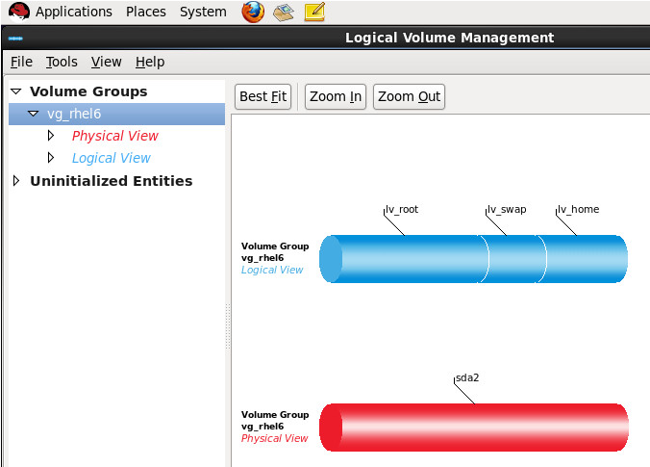
I will also increase the size of the single virtual disk by 5 GB (up to 25 GB). This is a pretty simple exercise and I covered how to do this briefly in an earlier post.
Once I did that, if I immediately go to the LVM GUI, I don’t see any difference. Even if I re-open LVM or go to “View” and “Reload,” I still don’t see any changes to the virtual disk inside the RHEL VM. I could just reboot the system and that should fix the problem, but rebooting isn’t always an option. Furthermore, if I can resize in Windows Server 2012 without a reboot, I’d like to see RHEL be able to do the same thing.
So, I’m going to use the fdisk command to see what the disk layout looks like in RHEL.
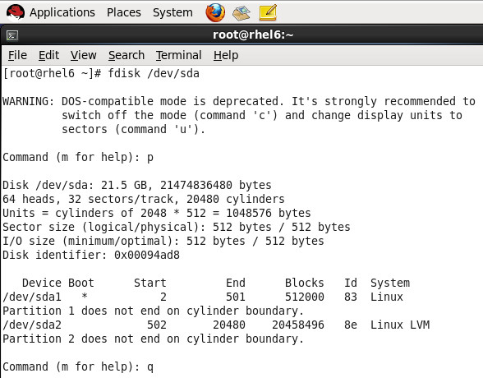
Without getting into the whole “bits vs. bytes” thing, I can see that /dev/sda is “21.5GB” which is my 20GB disk I originally created.
Now, I’m going to use some fancy magic to force RHEL to rescan for SCSI disks. Just by writing a ‘1’ to a special file, this will force RHEL to rescan.
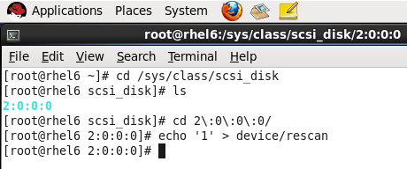
There’s no guarantee that the “2:0:0:0” path will be the same on every system, so this is something you will have to review once you’ve checked what’s in your /sys/class/scsi_disk directory.
Now, if I run fdisk again, I now see that my initial disk is now 26.8 GB, which means RHEL now sees the full-size 25 GB disk that I resized.
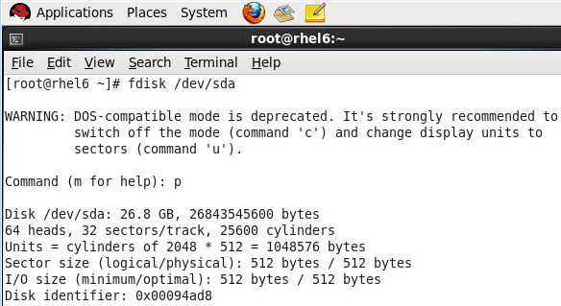
If I go back to LVM now, I will see a new “Unpartioned space” section show up.
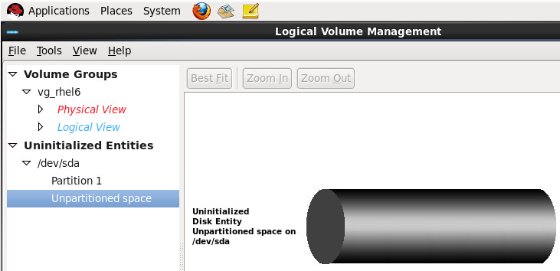
From this point, there’s two ways one can go ahead and use this extra space. Without introducing even more LVM terminology, I’m going to go with the option that the Linux community seems to agree on being the “safer” way to do things.

Creating a new partition
Next, what I’m going to do is set up this new unpartioned space by creating an entry in the partition table for it. In this case, I’m going to define it as a primary partition and give it the next available number which is “3” in this case.
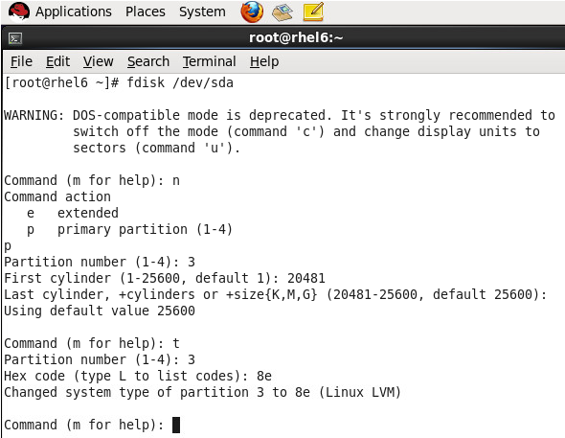
Above, one very important thing to do is to set the partition type to “8e” which is “Linux LVM” as shown above. If you miss this step, the process of adding the partition to LVM could cause major system problems, so be careful to not miss this important step in this scenario.
The value I used for the “first cylinder” is basically the next available number based on the previous fdisk output that shows that partition #2 ends at cylinder 20480.
The last step after having created a partition and setting the type is to write the changes to the partition table.
Attempting to write the partition table causes a warning message about doing a reboot, but also indicates that running partprobe can be done instead.
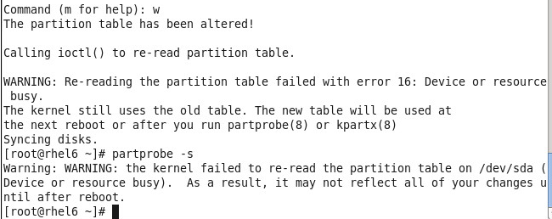
Unfortunately, partprobe doesn’t work in my case, so I’m going to reboot the system to avoid any issues. I don’t want to reboot, but I’m being cautious in this case to make sure I don’t cause any corruption.
After a reboot, if I open LVM to check things out, I now see that my un-partitioned space now looks different, and possibly usable.
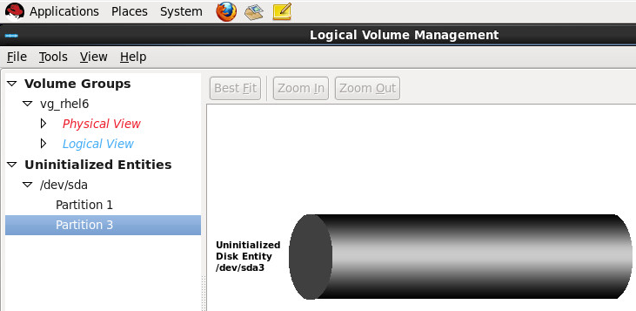

Volume group modification
Now, if I move on to the next thing, I need to do a few things in LVM to use the new partition. I’m going to go with the command-line for a bit, and try to display some visual information along with the commands I’m running.
First, I’m going to use the command “vgdisplay”, which is like “volume group display.” Based on the options chosen when I installed RHEL, the default volume group is named “vg_rhel6” in this case.
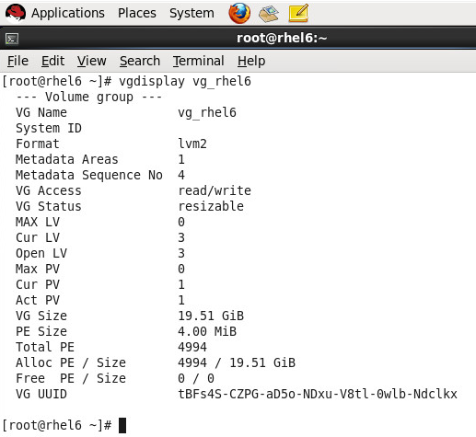
The important thing to note above is the VG Size value of 19.51 GiB. Now, I’m going to use the “vgextend” command (volume group extend) to modify my volume group to use the new partition that I just created.
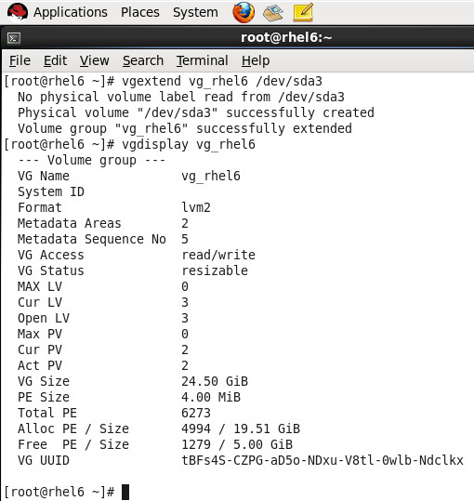
Just after extending the volume group above, I did another vgdisplay, and how I see the VG Size is now increased to 24.50 GiB.
To see what I’ve done so far, a peak at LVM shows what I have now.
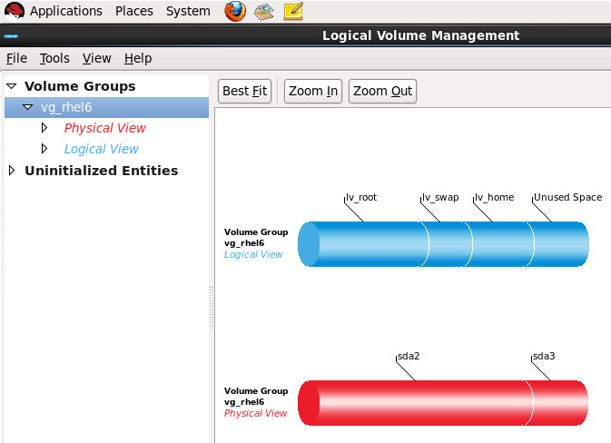
Above, I see that a new “Unused Space” section is now showing in the logical view of my volume group.

Logical volume modification
Now that I’ve added more unused space to the volume group, I need to modify my logical volume to use this new space.
I’m going to use the “lvextend” command (logical volume extend) to increase the size. In this case, I’m going to look at extending my / file system first, so I’ll modify the underlying logical volume.
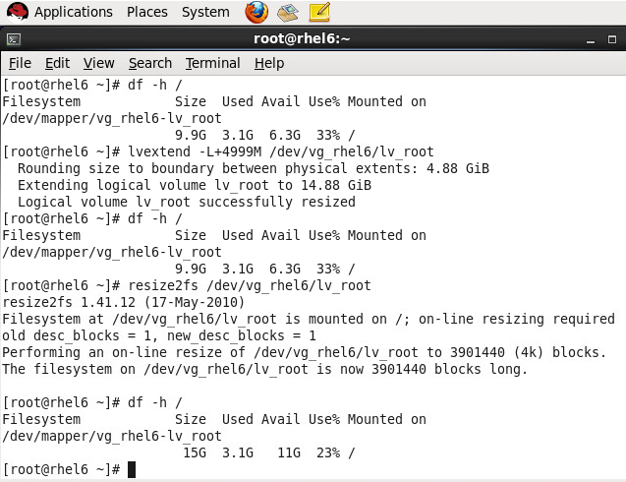
Above, I chose to use 4999M instead of 5G because the latter would return an error about not enough space being available. I’m not going to get into the specifics of these small calculations here.
I increased the logical volume above, but you may note that a second “df -h” command returned the same size for /. That’s because one more step is required, which is to resize the file system that basically sits on the logical volume, as shown. Once the file system is resized, a final “df -h” now shows that my / is now increased by 5GB basically.
Wait a minute!
If I have a single disk, I wasn’t able to resize a volume unless it was at the end of a disk. Linux doesn’t have that limitation when using the new LVM (technically known as “LVM2”).
So, with LVM, I can resize a disk no matter where it logically sits. For example, I can also resize /home, which was at the end of my disk before I resized it.
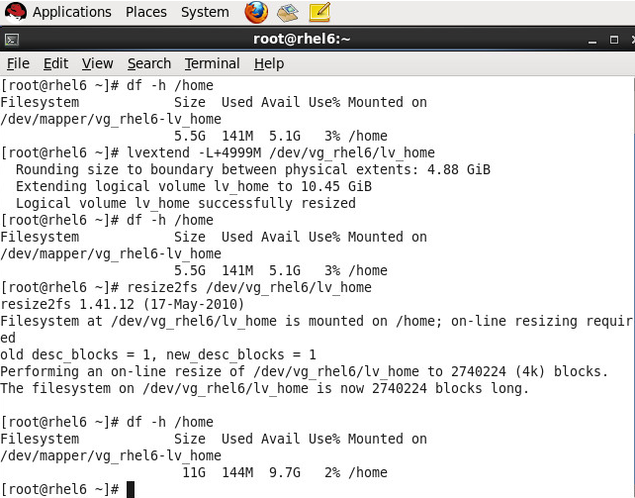
Again, I can resize a file system no matter where it seems to be on the disk.

Adding a second disk
Because of how LVM works, the earlier steps I would go through would also apply to how I would work with a second VMware “hard disk” added to the virtual machine. Instead of being seen as /dev/sda, it would be seen as /dev/sdb. I would still need to create a partition on it, extend the volume group, extend the logical volume and finally do another resize2fs.

Lesson learned
What I’ve gone through here with RHEL, is slightly different from what I encountered with Windows Server 2012.
I had limitations with Windows Server 2012 that no longer exist in RHEL, but remember that this is dependent on using LVM, otherwise, there are limitations that impact disk resizing, similar to the issues discussed in the Windows Server 2012 post, and I’ll cover those issues in a future post.
The important thing to consider here, above all else, is the importance of using LVM. You may want to stick with using a multi-disk setup, by considering a volume group per disk for example, but it is optional in this case.
It’s difficult to give the same clear guidance on best practices with RHEL as it was with Windows Server 2012, because RHEL with LVM is so much more flexible.
Remember, planning ahead can save a lot of headaches down the road.

http://blog.pluralsight.com/resize-vmware-windows-server-drives

Give me my space: How to resize Windows Server drives in VMware
By Marco Shaw
The ability to add virtual devices is awesome. Now sometimes, there’s some hard lessons to learn if someone jumps in without slowing down to think about certain things, like the guidelines defined up front.
One of the most common things that a system administrator will have to do in a virtualized environment is give out more RAM, CPU or disk space to a virtual machine. The whole point of virtualization is having the ability to dynamically change these values, but some can need more than a simple reboot, especially when it comes to resizing disks.
I’m going to go through the process of increasing the disk space of a virtual machine running Microsoft Windows Server 2012 running on VMware 5.1 (vSphere 5.1, ESXi 5.1 host and VMware tools installed). Along the way, I’m going to discuss a potential issue that can cause a lot of headaches, but ones that can be avoided with pre-defined guidelines or best practices.

A simple example
Let’s start with the simplest example where I have created a Windows Server 2012 VM with a single OS drive of 40 GB. You’ll see the Disk Management snapin will show below. Nothing much to see here except one single volume.
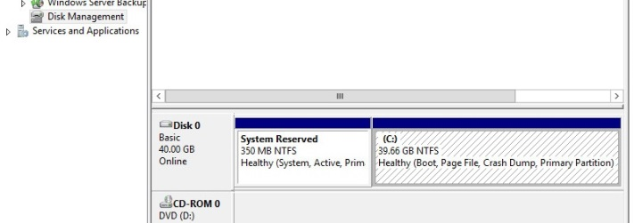
Here’s what the settings look like for this VM in VMware. We have one single hard disk. The fact that it’s configured as “lazy zeroed” is not important, and what I go through here applies to the other two types of disks you’ll find (“thin” and “eager zeroed”). Just remember that you won’t be able to resize the disk if it has a snapshot.
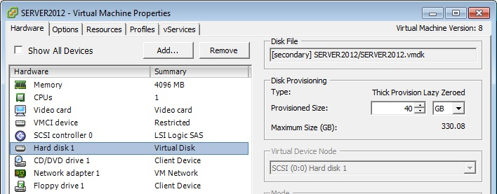
Let’s start off by increasing the size of this disk to 45 GB. You simply need to change the value in the above VM properties to the desired value and click OK. Pretty simple so far. We’ve increased the size of the underlying disk, but need to do a few things in the operating system now.
The first thing we’re going to do is to get the operating system to do a disk rescan, which is really simple to do via the Disk Management console, by simply selecting Rescan Disks.
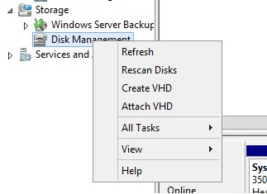
From here, we’ll see an extra amount of disk space show up in the console as “Unallocated.” We have the choice of what we want to do with this unallocated space, but in this example, we want to use this space to increase the current size of the operating system drive.
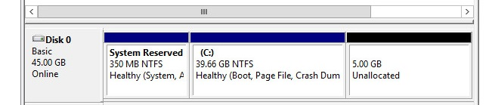
This shows one of the awesome improvements in Windows Server. In Windows Server 2003, resizing the OS drive wasn’t possible, but this changed in Windows Server 2008.
So now that we have our “extra space,” resizing the OS drive is another simple task. Just by right-clicking on the partition, we have an “Extend Volume” option. This will fire up a pretty simple wizard (not shown). For example, you can choose whether you want to use the full size of the unallocated space.
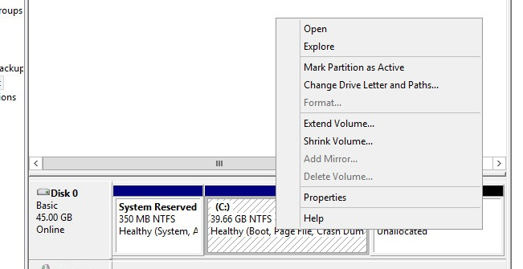
After the wizard finishes, your disk is now resized as you requested. This is all done while the operating system is running, too! This is the magic that virtualization provides. Think about how much effort it would take to do something like this on a physical server.
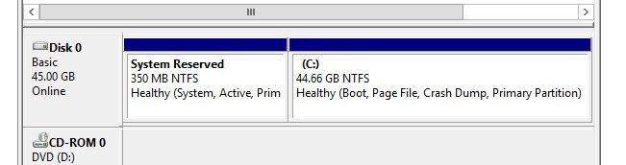

Bad setup for future increases
Now, let’s say we have a setup with two volumes on one single disk. What happens if we need to increase the space of a volume? Does it matter which volume?
Based on the previous example, we just need to resize the disk in VMware, and then extend the volume, right? Here’s where we might have a problem.
This is what our disk looks like when we have two volumes on the same disk. The important thing to note is that C: is not the last volume on the disk, while E: is at the end.
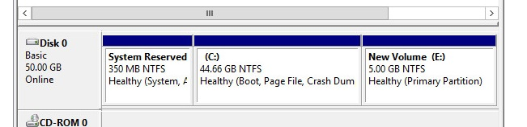
If we go through the same kind of process as before (not show again here), we increase the size of the single disk and do a rescan, the result would look something like this:
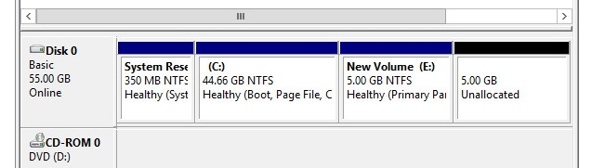
So, if the goal was to increase the size of the C: drive then by simply right-clicking on the drive, it could be extended as before. Hold on–there’s a problem, because when the drive is right-clicked on, the “Extend Volume” option is disabled. Remember that the C: drive is not at the end of the drive.
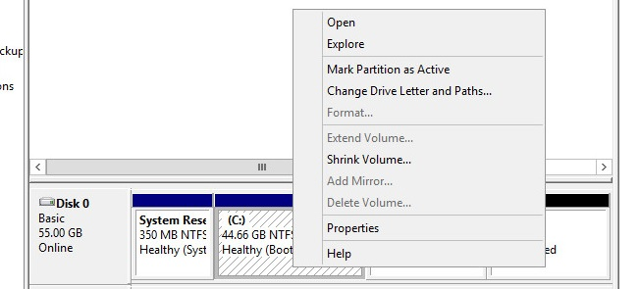
OK, will I see the same behavior if I tried to extend the E: drive instead, right? Remember that this volume is at the end of the drive. Now I have the “Extend Volume” option available and can use it.
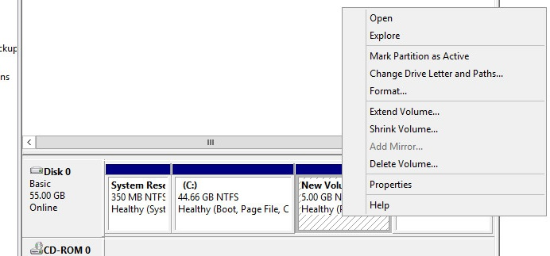

Lesson learned
The important takeaway from the previous example is if you are trying to resize a volume, then it either has to be the only volume on the disk or must be at the end of the disk. The problem is that a volume can’t be moved by the built-in features.

Guideline: One volume per disk
I want to show you how easy it is to resize a disk, but also to offer a practical example to show how important it is to plan and design virtual machines properly at setup.
A best practice or guideline in a virtualized environment is to look at having a “one volume per disk” policy or guideline. It can save you a lot of trouble in the future, especially in a virtualized environment, where all of a sudden you need to increase the size of a volume.
In the original example above, we had a single volume on a single disk, and then we moved on to two volumes on a single disk.
The better way to setup two volumes on a virtual machine would be to have two disks, so that each volume had its own dedicated disk.

Setting up a second disk
In this next example, if I started off with a system with a single disk, and wanted to add a second disk it would be as simple as adding the proper virtual hardware to the virtual machine as shown below.
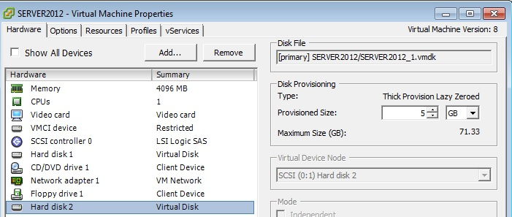
I’ve skipped a few steps between having a single disk/volume to having the setup below where I have my C: and E: volumes on different drives. Once you add a new disk to an existing Windows Server virtual machine you have to bring the disk online, initialize it and create a volume on it (not shown).
This is what a better setup looks like:
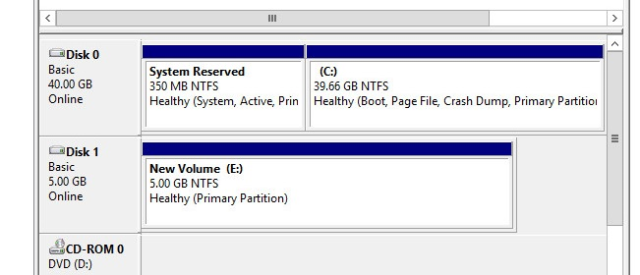
In this last example, I don’t have any constraints if I need to increase the size of either my C: or E: drives because now they are either the only volume on the disk or are at the end.
Want to learn more about Windows Server 2012? Sign up for a 3-day free trialto access TrainSignal’s complete training library, including Windows Server 2012 Installing and Configuring and more Microsoft courses.

